CreateElement

<html>

    <head>

        <title>CreateElement</title>

    </head>

    <body>

        <h1>createElement()</h1>

        <script>

            const para = document.createElement("p");

            para.innerText = "Hello Prashanna raj";

            document.body.appendChild(para);

        </script>

    </body>

</html>

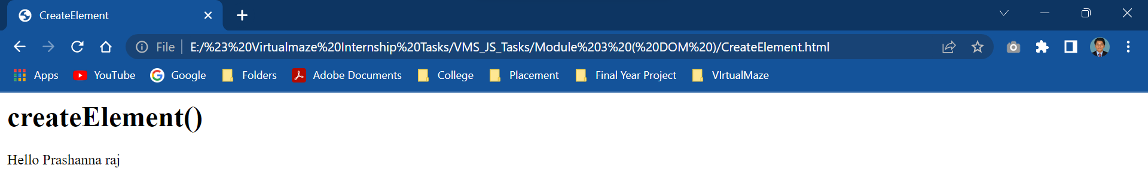

<html>

<body>

<h2>The createElement() Method</h2>

<div id="demo" style="padding:16px;background-color:lightgray">

<h3>A DIV element</h3>

</div>

<script>

const para = document.createElement("p");

para.innerHTML = "I am using Asus Laptop.";

document.getElementById("demo").appendChild(para);

</script>

</body>

</html>

